We have discussed-
- A schedule is the order in which the operations of multiple transactions appear for execution.
- Serial schedules are always consistent.
- Non-serial schedules are not always consistent.
In DBMS, schedules may be classified as-
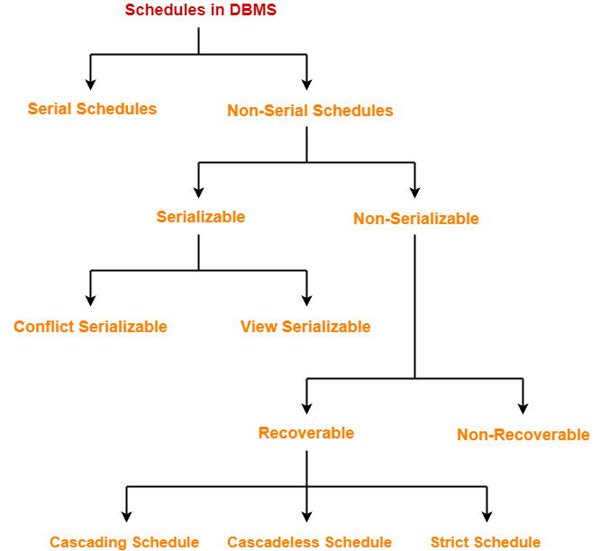

Serializability in DBMS-

- Some non-serial schedules may lead to inconsistency of the database.
- Serializability is a concept that helps to identify which non-serial schedules are correct and will maintain the consistency of the database.

Serializable Schedules-

If a given non-serial schedule of ‘n’ transactions is equivalent to some serial schedule of ‘n’ transactions, then it is called as a serializable schedule.

Serializable schedules behave exactly same as serial schedules.
Thus, serializable schedules are always-
- Consistent
- Recoverable
- Casacadeless
- Strict

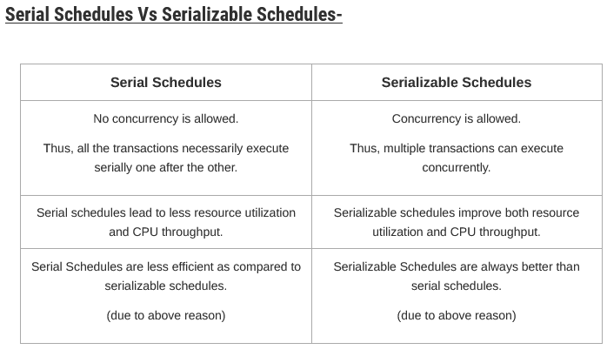

Types of Serializability-

Serializability is mainly of two types-
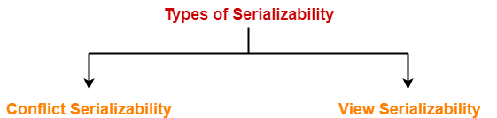

Conflict Serializability-

If a given non-serial schedule can be converted into a serial schedule by swapping its non-conflicting operations, then it is called as a conflict serializable schedule.

Conflicting Operations-

Two operations are called as conflicting operations if all the following conditions hold true for them-
- Both the operations belong to different transactions
- Both the operations are on the same data item
- At least one of the two operations is a write operation

Example-

Consider the following schedule-
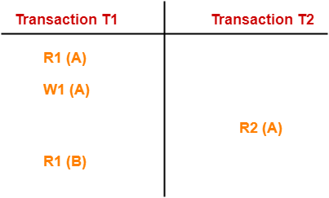

Checking Whether a Schedule is Conflict Serializable Or Not-

Follow the following steps to check whether a given non-serial schedule is conflict serializable or not-

Step-01:

Find and list all the conflicting operations.

Step-02:

Start creating a precedence graph by drawing one node for each transaction.

Step-03:

- Draw an edge for each conflict pair such that if X_{i} (V) and Y_{j} (V) forms a conflict pair then draw an edge from T_{i} to T_{j}.
- This ensures that T_{i} gets executed before T_{j}.

Step-04:

- Check if there is any cycle formed in the graph.
- If there is no cycle found, then the schedule is conflict serializable otherwise not.

Check whether the given schedule S is conflict serializable or not-
S : R₁(A) , R₂(A) , R₁(B) , R₂(B) , R₃(B) , W₁(A) , W₂(B)

Step-01:

List all the conflicting operations and determine the dependency between the transactions-
- R₂(A) , W₁(A) (T₂ → T₁)
- R₁(B) , W₂(B) (T₁ → T₂)
- R₃(B) , W₂(B) (T₃ → T₂)

Step-02:

Draw the precedence graph-
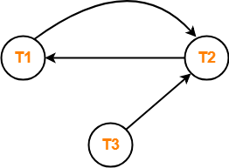

- Clearly, there exists a cycle in the precedence graph.
- Therefore, the given schedule S is not conflict serializable.

Problem-02:

Check whether the given schedule S is conflict serializable and recoverable or not-
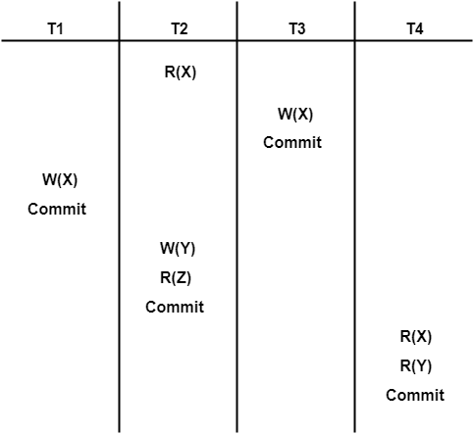

Step-01:

List all the conflicting operations and determine the dependency between the transactions-

- R₂(X) , W₃(X) (T₂ → T₃)
- R₂(X) , W₁(X) (T₂ → T₁)
- W₃(X) , W₁(X) (T₃ → T₁)
- W₃(X) , R₄(X) (T₃ → T₄)
- W₁(X) , R₄(X) (T₁ → T₄)
- W₂(Y) , R₄(Y) (T₂ → T₄)

Step-02:

Draw the precedence graph-
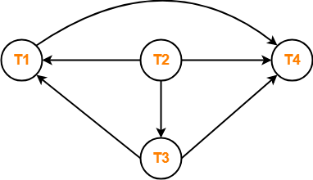

- Clearly, there exists no cycle in the precedence graph.
- Therefore, the given schedule S is conflict serializable.

Checking Whether S is Recoverable Or Not-

- Conflict serializable schedules are always recoverable.
- Therefore, the given schedule S is recoverable.

View Serializability-

View Equivalent Schedules-

Consider two schedules S1 and S2 each consisting of two transactions T1 and T2.
Schedules S1 and S2 are called view equivalent if the following three conditions hold true for them-

Condition-01:

For each data item X, if transaction T_{i} reads X from the database initially in schedule S1, then in schedule S2 also, T_{i} must perform the initial read of X from the database.

Condition-02:

If transaction T_{i} reads a data item that has been updated by the transaction T_{j} in schedule S1, then in schedule S2 also, transaction T_{i} must read the same data item that has been updated by the transaction T_{j.}

Condition-03:

For each data item X, if X has been updated at last by transaction T_{i} in schedule S1, then in schedule S2 also, X must be updated at last by transaction T_{i}.

Checking Whether a Schedule is View Serializable Or Not-

Method-01:

Check whether the given schedule is conflict serializable or not.
- If the given schedule is conflict serializable, then it is surely view serializable. Stop and report your answer.
- If the given schedule is not conflict serializable, then it may or may not be view serializable. Go and check using other methods.

Method-02:

Check if there exists any blind write operation.
(Writing without reading is called as a blind write).
- If there does not exist any blind write, then the schedule is surely not view serializable. Stop and report your answer.
- If there exists any blind write, then the schedule may or may not be view serializable. Go and check using other methods.

Method-03:

In this method, try finding a view equivalent serial schedule.
- By using the above three conditions, write all the dependencies.
- Then, draw a graph using those dependencies.
- If there exists no cycle in the graph, then the schedule is view serializable otherwise not.

PRACTICE PROBLEMS BASED ON VIEW SERIALIZABILITY-

Problem-01:

Check whether the given schedule S is view serializable or not-
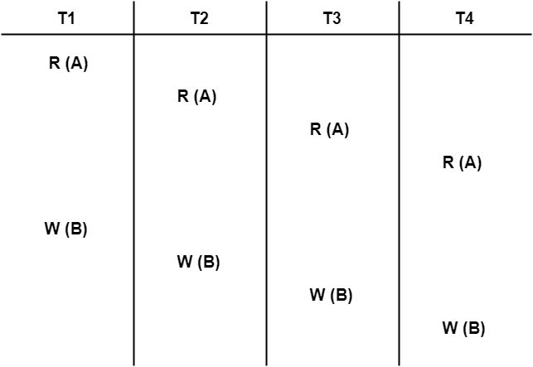

Solution-

- We know, if a schedule is conflict serializable, then it is surely view serializable.
- So, let us check whether the given schedule is conflict serializable or not.

Checking Whether S is Conflict Serializable Or Not-

Step-01:
List all the conflicting operations and determine the dependency between the transactions-
- W₁(B) , W₂(B) (T₁ → T₂)
- W₁(B) , W₃(B) (T₁ → T₃)
- W₁(B) , W₄(B) (T₁ → T₄)
- W₂(B) , W₃(B) (T₂ → T₃)
- W₂(B) , W₄(B) (T₂ → T₄)
- W₃(B) , W₄(B) (T₃ → T₄)

Step-02:

Draw the precedence graph-
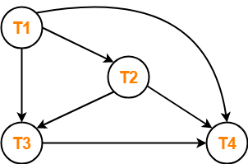
- Clearly, there exists no cycle in the precedence graph.
- Therefore, the given schedule S is conflict serializable.
- Thus, we conclude that the given schedule is also view serializable.

Problem-02:

Check whether the given schedule S is view serializable or not-

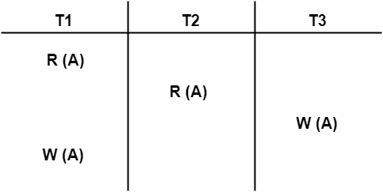

Solution-

- We know, if a schedule is conflict serializable, then it is surely view serializable.
- So, let us check whether the given schedule is conflict serializable or not.

Checking Whether S is Conflict Serializable Or Not-

Step-01:

List all the conflicting operations and determine the dependency between the transactions-
- R₁(A) , W₃(A) (T₁ → T₃)
- R₂(A) , W₃(A) (T₂ → T₃)
- R₂(A) , W₁(A) (T₂ → T₁)
- W₃(A) , W₁(A) (T₃ → T₁)

Step-02:

Draw the precedence graph-

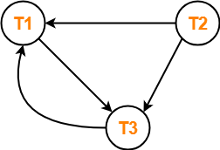
- Clearly, there exists a cycle in the precedence graph.
- Therefore, the given schedule S is not conflict serializable.

Now,
- Since, the given schedule S is not conflict serializable, so, it may or may not be view serializable.
- To check whether S is view serializable or not, let us use another method.
- Let us check for blind writes.

Checking for Blind Writes-

- There exists a blind write W₃ (A) in the given schedule S.
- Therefore, the given schedule S may or may not be view serializable.

Now,
- To check whether S is view serializable or not, let us use another method.
- Let us derive the dependencies and then draw a dependency graph.

Drawing a Dependency Graph-

- T1 firstly reads A and T3 firstly updates A.
- So, T1 must execute before T3.
- Thus, we get the dependency T1 → T3.
- Final updation on A is made by the transaction T1.
- So, T1 must execute after all other transactions.
- Thus, we get the dependency (T2, T3) → T1.
- There exists no write-read sequence.
Now, let us draw a dependency graph using these dependencies-
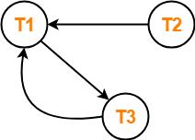
- Clearly, there exists a cycle in the dependency graph.
- Thus, we conclude that the given schedule S is not view serializable.

Problem-03:

Check whether the given schedule S is view serializable or not-
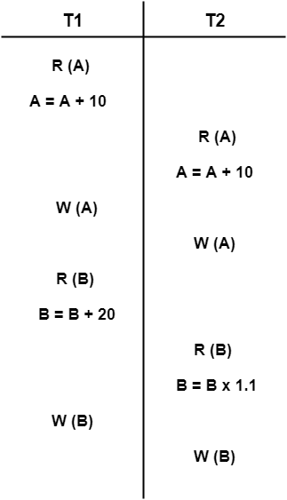

Solution-

- We know, if a schedule is conflict serializable, then it is surely view serializable.
- So, let us check whether the given schedule is conflict serializable or not.

Checking Whether S is Conflict Serializable Or Not-

Step-01:

List all the conflicting operations and determine the dependency between the transactions-
- R₁(A) , W₂(A) (T₁ → T₂)
- R₂(A) , W₁(A) (T₂ → T₁)
- W₁(A) , W₂(A) (T₁ → T₂)
- R₁(B) , W₂(B) (T₁ → T₂)
- R₂(B) , W₁(B) (T₂ → T₁)

Step-02:

Draw the precedence graph-
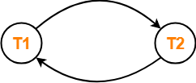
- Since, the given schedule S is not conflict serializable, so, it may or may not be view serializable.
- To check whether S is view serializable or not, let us use another method.
- Let us check for blind writes.

Checking for Blind Writes-

- There exists no blind write in the given schedule S.
- Therefore, it is surely not view serializable.

